Pathways and priority interventions for halving premature death worldwide by mid-century: a modeling study

David Watkins,^{1,2} Sali Ahmed,² Ana Castillo,² Zahra Zeinali,² William Msemburi,³ Jan-Magnus Økland,⁴ Dean Jamison,⁵ Gunjeet Kaur (?),⁶ Amalie Merkesvik,⁷ Ole Frithjof Norheim,^{4,8} Sarah Pickersgill (?),³ Øystein Haaland,^{4,*} Kjell Arne Johannson^{4,*}
* Joint senior authors
- Division of General Internal Medicine, University of Washington
- Department of Global Health, University of Washington
- Independent Consultant
- Bergen Center for Ethics and Priority Setting, Department of Global Public Health and Primary Care, University of Bergen
- Institute for Global Health Sciences, University of California San Francisco
- Saw Swee Hock School of Public Health, National University of Singapore
- Faculty of Medicine, University of Bergen
- Harvard T.H. Chan School of Public Health, Harvard University

Correspondence to:
David A. Watkins, MD, MPH
Hans Rosling Center for Population Health
3980 15th Ave NE
Seattle, WA 98195
davidaw@uw.edu

Word count: #### / 3000

Introduction
- Mortality trends pre and post pandemic
- Health financing landscape and need to prioritize
- CIH report – priority conditions and intervention modules
- Objective: identify high-priority interventions for focused scale-up to achieve 50x50

Methods
- Methods appendix here, in progress
- Description of impact model, demography model, and cost model
- Intervention database/input data (add 2nd appendix with PDFs of all evidence briefs)
- Introduce the 15 priority conditions (see panel from CIH report, end of this doc)
- Analyses, done for 195 countries and 10 CIH regions (see figure from CIH report, end of this doc):
  - Cost-effectiveness of different interventions and modules
    - Appendix: compare $/70q0 to $/HLY as in NCD countdown
    - This time, include tobacco taxes and regulations (not currently in FC but can pull data from NCD countdown and include in model)
  - Efficient pathways towards 50x50 target
    - Similar to NCD countdown, but EXCLUDE non C-E interventions from each package
    - Sequence conditions from largest to smallest impact on 70q0 in each country (TBC, need to discuss)
- Scenario analyses: accelerated and reduced met need for family planning
- Ethics, role of funder, etc.

Dummy tables and figures for results

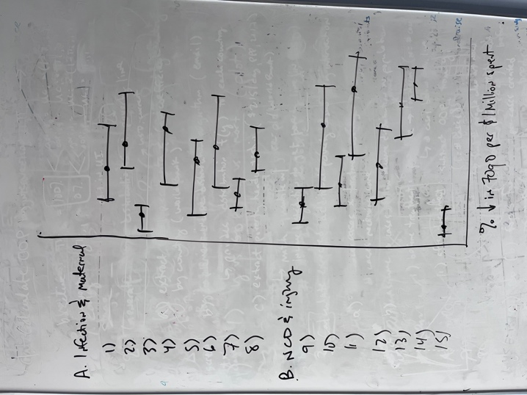
Figure X. Intervention cost-effectiveness by condition. Each row denotes the range of cost-effectiveness ratios for FairChoices interventions addressing that condition. The left bar denotes the most cost-effective intervention, and the right bar denotes the least cost-effective intervention. The aggregate effect of all interventions within that group is shown as the central dot. Cost-effectiveness ratios are calculated one by one for each intervention (or in the case of the central dot, all interventions addressing that condition) for a standardized 10% increase in coverage sustained over 2025-2050. Results are reported as the aggregate (population-weighted) cost-effectiveness across 195 countries.

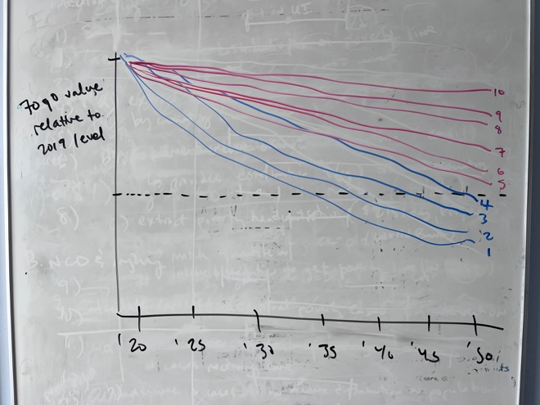
Figure Y. Prospects for achieving the 50x50 target, by world region. The plot shows the trend in 70q0 over time by world region, relative each region’s 2019 value for 70q0. The trend assumes that the intervention pathway outlined in the methods section is followed and that the priority interventions are fully implemented by 2050. The dotted line denotes a 70q0 that is 50% lower than the 2019 level, and trendlines that cross this threshold indicate that the target has been achieved in that region. Of course, individual countries within each region will have different trajectories better or worse than the average; see the appendix for plots of individual countries within each region.

Table A. Overall impact and cost of achieving the 50x50 target, by world region.
Region | Change in 70q0 (2050 vs. 2019) | Premature deaths averted (millions) | Cumulative incremental costs (US$, billions) | Average annual incremental cost as a share of 2023 GNI
Central Asia | -##% | ## | $## | %
Central and Eastern Europe | -##% | ## | $## | %
China | -##% | ## | $## | %
India | -##% | ## | $## | %
Latin America and Caribbean | -##% | ## | $## | %
Middle East and North Africa | -##% | ## | $## | %
North Atlantic | -##% | ## | $## | %
Sub-Saharan Africa | -##% | ## | $## | %
Western Pacific and Southeast Asia | -##% | ## | $## | %
USA | -##% | ## | $## | %
Notes: all costs are presented in constant 2023 US dollars.

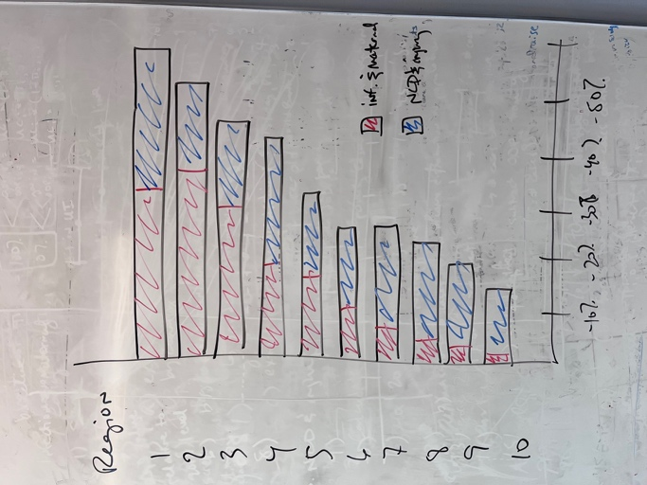
Figure Z. Contribution of different conditions to reductions in 70q0 and achievement of the 50x50 target. The lengths of the bars indicate the overall reduction in 70q0 by 2050 (relative to 2019) with full implementation of priority interventions. The colors indicate the shares of that reduction due to the 15 different priority conditions. (NB Will: I only show 2 colors here, but you get the idea. We can do this with 15 different colors I hope.)

Table B. Findings from scenario analysis on family planning.
Indicator | Higher-fertility regions |  |  | Lower-fertility regions
Indicator | Worse | Base case | Better | Worse | Base case | Better
Change in total population
Change in total deaths
Change in CDR
Change in working-age population
Change in CDR*
Change in old-age dependency ratio
Notes: “Higher-fertility regions” are defined as regions that had a TFR of #.# or higher in 2019; these were sub-Saharan Africa, ###, and ###. (NB: Will we should discuss how to group or whether just to separate SSA from the other regions.) The other # regions are grouped into “lower-fertility regions” category. The “base case” scenario, which we use throughout the rest of this paper, assumes secular trends in age-specific fertility rates 2010-2019 continue through 2050. The worse scenario assumes rates remain at 2019 levels. The better scenario assumes full met need for family planning by 2050. (Data on unmet need for family planning come from the Guttmacher Institute.) CDR = crude death rate per 1000 population; CDR* = crude death rate per 1000 working-age population.

Additional information from CIH report
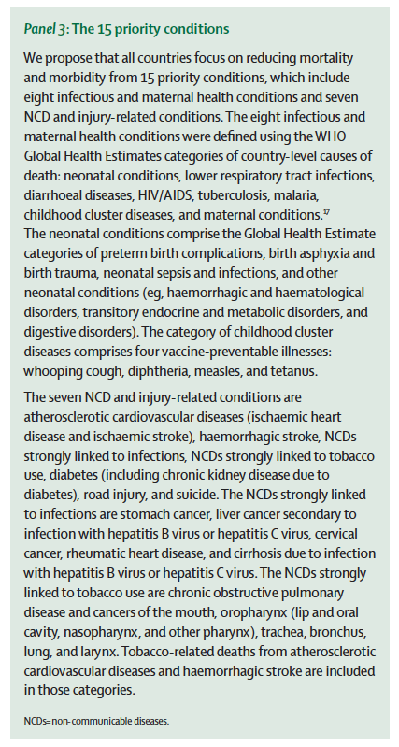
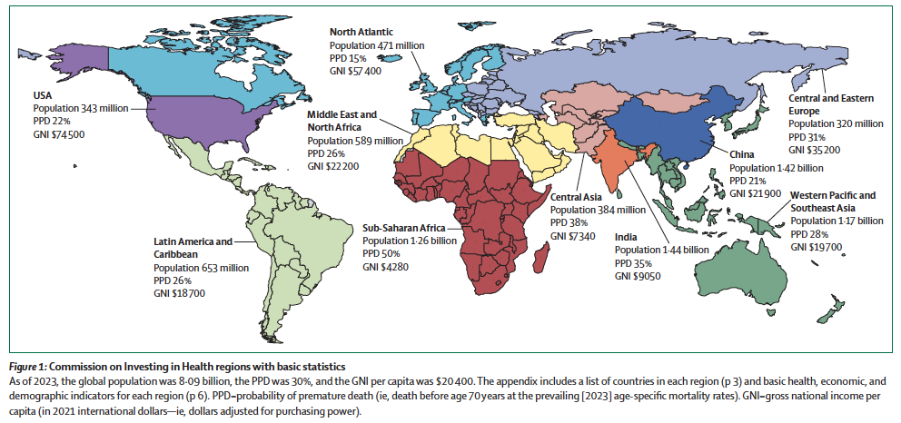
NB: will be included in the footnotes of one or more tables/figures and/or in the appendix.

